Configuring and Upgrading Firmware on a Cradlepoint:
Things you will need:
- Cradlepoint Config File
(https://drive.google.com/drive/folders/0Bxq9yzLn-S_-V3JWTC1TNjk5TVk)
- Ethernet Cable
- Cradlepoint
- Access to power outlet for the power supply
Step 1: Pull the cradlepoint out of the box, plug in the power supply to the outlet and the back of the cradlepoint, and connect your Ethernet cable to the cradlepoint and your PC. Turn on the switch on the back of the cradlepoint (if it isn’t already on).
Step 2: Wait for it to boot itself up and obtain an internet connection.
Step 3: Once it is connected, this screen should pop up in your browser, and you will need to click “Click here to see administration console” (see image below). If the screen does not come up automatically, just type “cp/” in your web browser address bar to get to the administration console login screen.
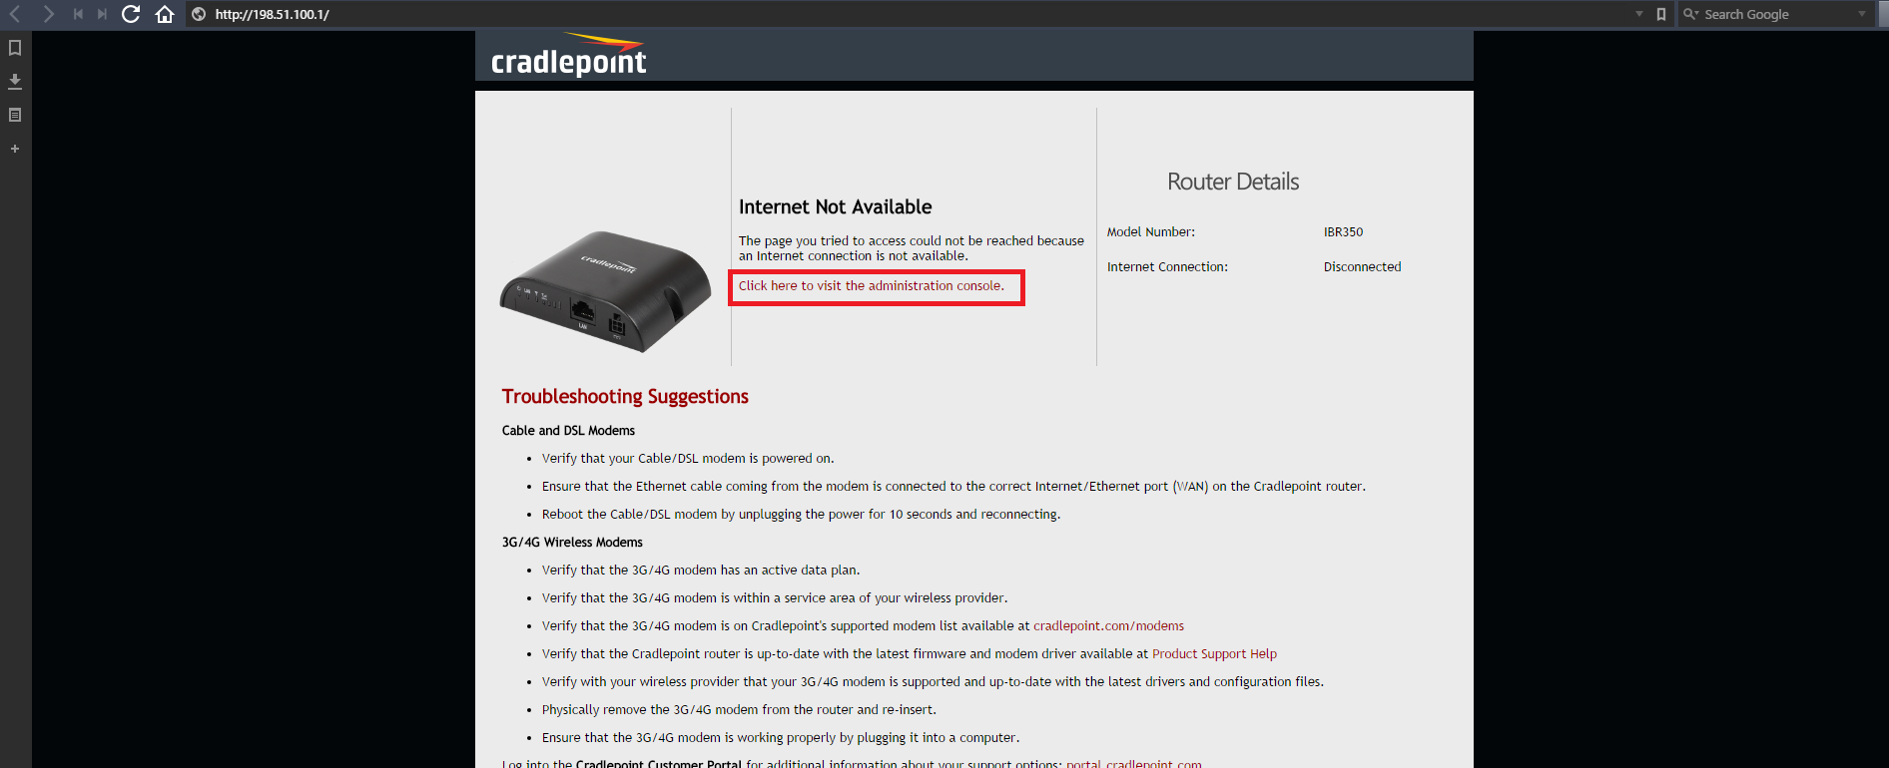
Step 4: Once you click the link and get redirected to the administration panel, it will prompt you for a password. This password is going to be the “Default Password: xxxxxxxx” on the back of the cradlepoint.
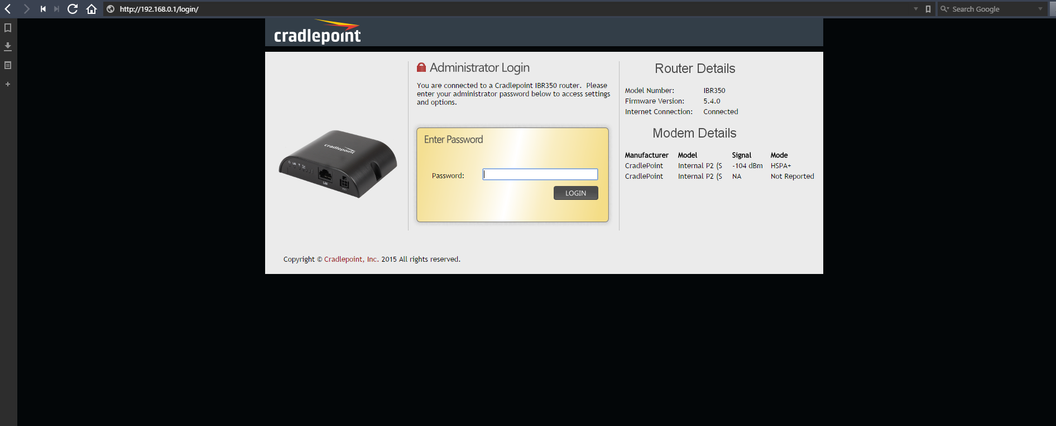
Step 5: Once you are at the dashboard of the administration console, you must document the following: Serial, MAC Address, and IP Address in the google sheet titled Cradlepoint Sheet (can be found by searching the SBE Shared google drive).
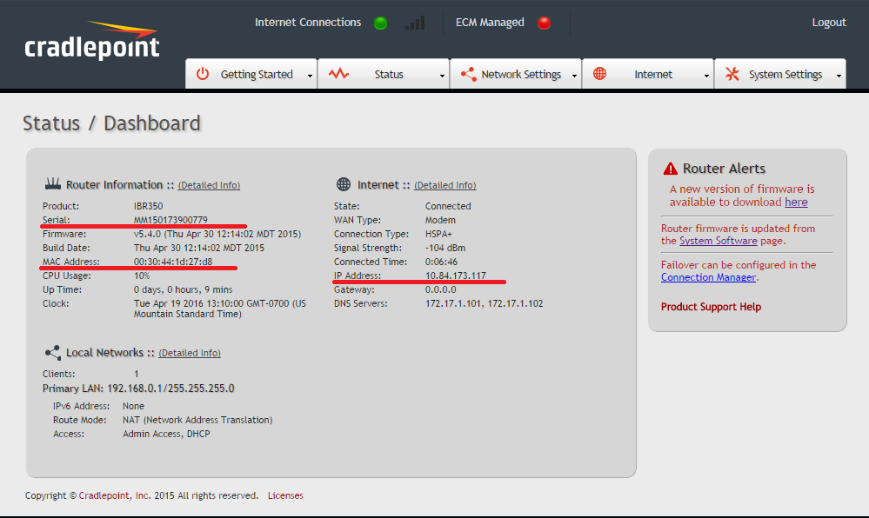
Step 6: Click the System Software link found in the “Router Alerts” box on the right side of the screen.
Step 7: Under where it says System Config Save / Restore, click “Upload from File” and find the Cradlepoint config file you were provided with, and select it. Then click restore settings.
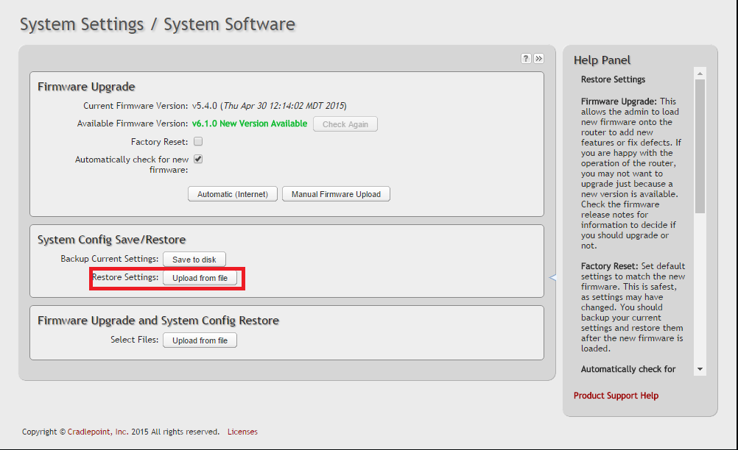
Step 8: The device will now install the new configuration file, and reboot itself. Once it reboots, the administration console login page will pop back up, only this time the password to login with is “SmallB0x3n3rgy” (the o in Box is a zero, not an o).
Note: If the administration console does not automatically reload, type “cp/” in your web browser address bar, and as long as the cradlepoint has already finished connecting to the internet it will load the admin console.
Step 9: Go back to the system software page. Once you see a green light at the top signifying that there is an internet connection, under Firmware Upgrade click “Check Again” and the Available Firmware Version will read in green “v6.1.0 New Version Available.” Click the “Automatic (Internet)” button, and the device will start flashing the new firmware.
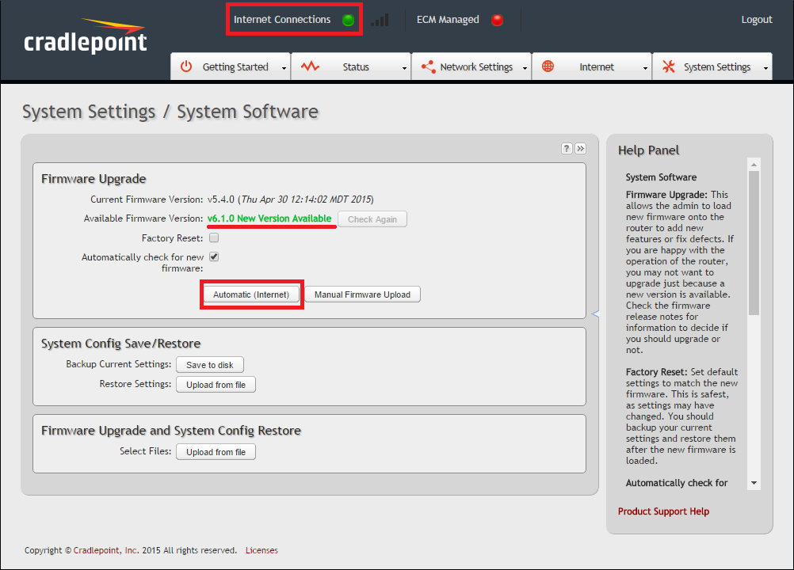
Step 10: Once the cradlepoint is finished installing the new firmware and rebooting, the administration console will pop up yet again, but this time it should look entirely different (see below). Once you reach this step, the process is complete.
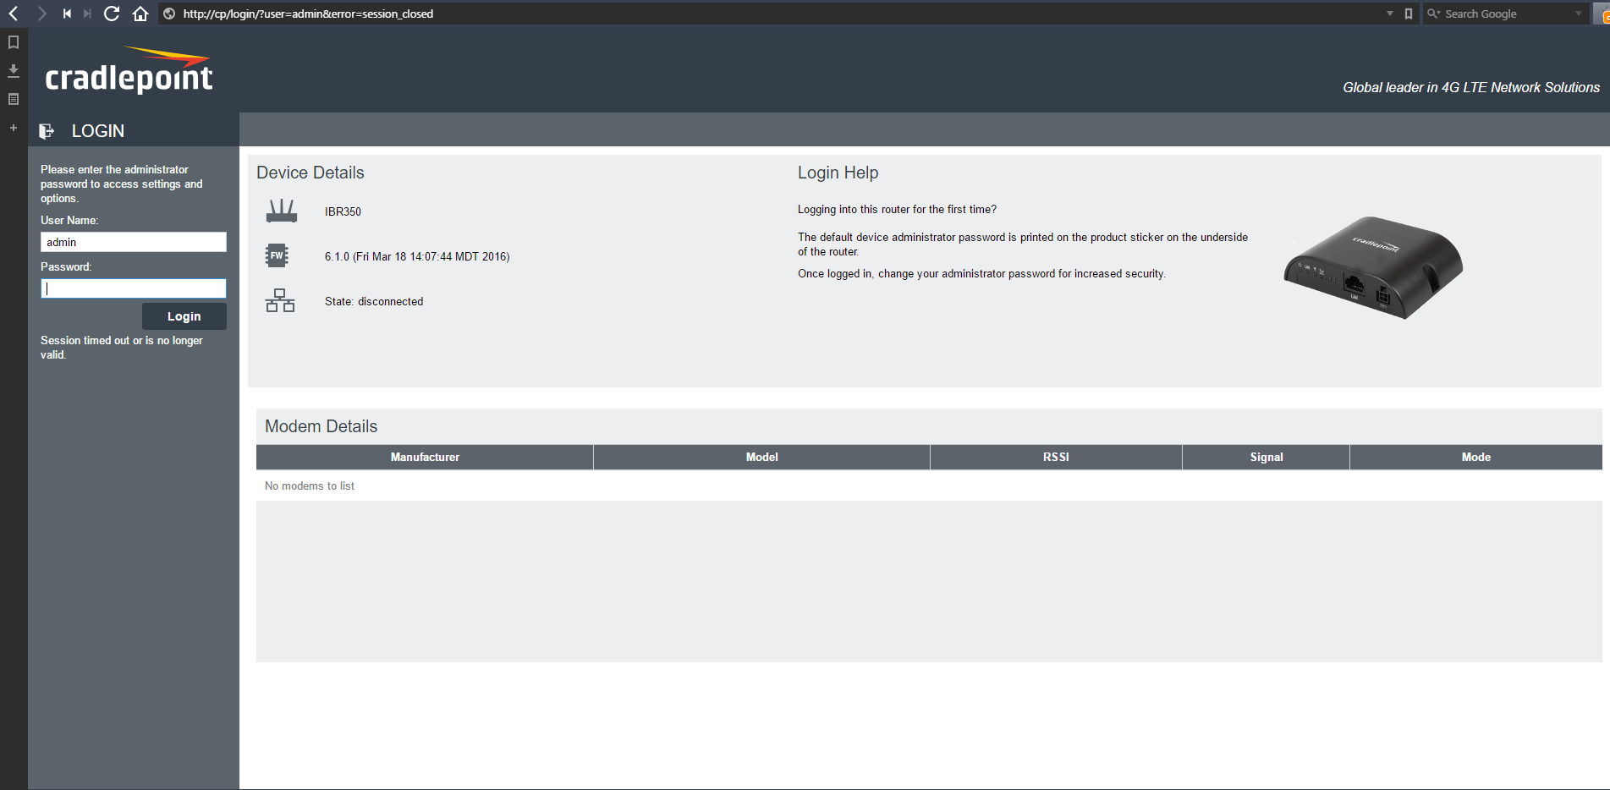
Step 11: Unplug, and re-box the cradlepoint.

